2019 American Fidelity
KASBO State Convention Scholarship Program

This application should be used if you wish to apply for a KASBO scholarship.

2019 KASBO State Convention
April 24-26, 2019
Hampton Inn & Suites I-35, Mulvane, KS
Website: https://kasbo.wildapricot.org/

As a Prestigious Partner with KASBO, American Fidelity is the proud sponsor of the American Fidelity KASBO State Convention Scholarship Program. This program provides an excellent opportunity for new and aspiring school business officials to become part of the KASBO family. The scholarships provide financial assistance to attend the KASBO state convention, where you will be able to network with colleagues, participate in professional development, and explore the variety of school business resources that KASBO has to offer.

What Does the Scholarship Cover?
American Fidelity will award ten (10) KASBO Convention Scholarships. The scholarships will pay for an annual membership, convention registration and a hotel room for two nights. This year, the KASBO Convention will be held in Mulvane, KS on April 24-26 at the Hampton Inn & Suites I-35.

Do I Qualify?
The KASBO Convention Scholarship applicant should be a school business official who would not be likely to attend due to a lack of funding from their school district, or a school business employee that has never attended the annual KASBO Convention. Top priority will be given to new attendees and attendees who would be willing to share a hotel room in order to maximize scholarship funds.

How Do I Apply?
Applicants should complete the application form provided. The form should be emailed to
Merle Hastert at mhastertec@olatheschools.org by March 01, 2019. KASBO scholarship recipients will be notified in early February or shortly thereafter.
All scholarship checks will be made payable to the recipient’s district.

Who do I contact if I have questions?
Please contact Merle Hastert at (913) 780-8035 or at mhastertec@olatheschools.org if you have questions or need additional information.

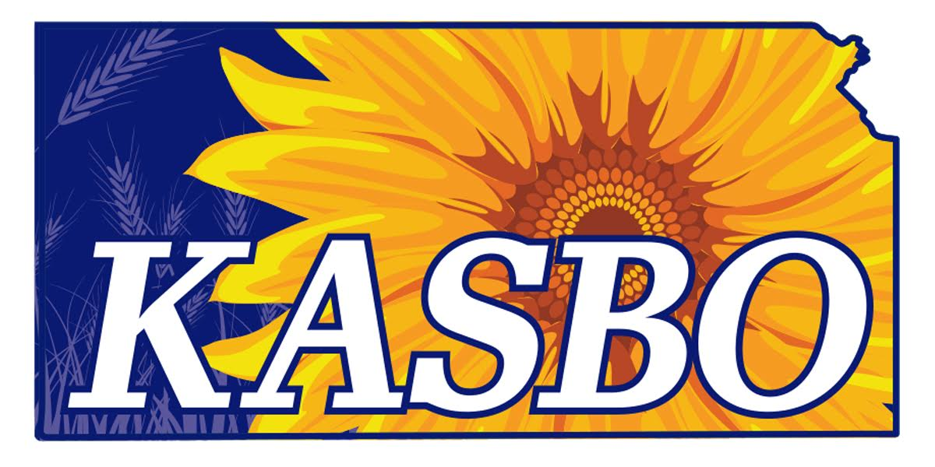
2019 American Fidelity
KASBO State Convention Scholarship Application

Application Deadline March 01, 2019
Completed Application should be sent to Merle Hastert
Email: mhastertec@olatheschools.org

Name ______________________________________ Title / Position________________________
First / Middle Initial / Last

USD Name & No. ______________________________ Email ______________________________

Street Address, City & Zip __________________________________________________________

Work Phone Number __________________________ Years in School Business _______________

Signature ___________________________________ Date________________________________

Please complete the following questions. Please limit each response to 100 words or less.

1. Have you ever attended a KASBO State Convention? ______

- If YES, give dates and experience gained.

2. What are your short-term and long-term professional goals? How do the responsibilities and
roles in your current position promote advancement of those goals?

3. Why are you interested in applying for the KASBO Scholarship Program and what value
do you believe you will bring to the program?

4. How will you utilize the experience of the KASBO Scholarship Program in order to
contribute to the school business profession?

