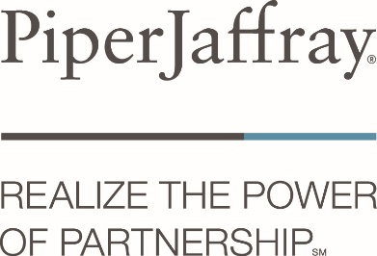

2019 KASBO Dependent Scholarship Program
Sponsored by Piper Jaffray

The Kansas Association of School Business Officials (KASBO) and proud sponsor Piper Jaffray are
honored to offer to active KASBO members an opportunity for their immediate dependents to apply
for a $1,000 Academic Scholarship to be awarded each year at our annual KASBO spring conference.

The deadline for receipt of applications is March 1, each year, and must be submitted to:
KASBO
PO Box 8786
Topeka, KS 66608

or send to Merle Hastert: mhastertec@olatheschools.org

Eligibility requirements:
Applicants must meet the following requirements for consideration:
- Must be a dependent of an active member of KASBO (2018-19 member at the time of application submission and 2019-20 member at the time of scholarship award)
- Must be graduating in May of the application year
- Show character, citizenship and dependability traits which would indicate success in an institution of higher learning
- Acceptance into an institution of higher learning; start date within 4 months of high school graduation

Awarding of scholarship:
Selection process is based on an evaluation of material received from all applicants.
- A recommendation will be made based on leadership, citizenship, academics, and extra-curricular participation. (regardless of age, sex, religion, color, race, national origin, or disability)
- Check will be made payable to recipient and learning institution upon confirmation of enrollment from admitting institution.
- Award is a one-time award for $1,000. Does not renew annually.
- In the event the recipient of the scholarship is not enrolled in an institution of higher learning by
October 15 of the awarded year, the award will be held over for the following year scholarship selection process with one (1) additional scholarship award being offered.

We wish all candidates success in their future endeavors!!!!


2019 KASBO Dependent Scholarship Application
Sponsored by Piper Jaffray

Application Deadline: March 01, 2019

Completed Application should be mailed to:
KASBO
PO Box 8786
Topeka, KS 66608
or send to Merle Hastert: mhastertec@olatheschools.org

PART A

KASBO Member ________________________________ Title/Position_______________________
First / Last

USD Name & No. _______________________________ Email _____________________________

Work Phone Number ____________________________ 2018/2019 KASBO Member? Yes / No
Circle one
Signature Date______________________________

PART B

Dependent Name __________________________ Relationship to KASBO member ____________
First / Last

Current High School ________________________ Expected Graduation Date ________________

Application and Required Submission Items:

All applicants are required to submit the above information and the following items:
- Free form cover letter of application that includes (at a minimum) the following information:
  - Why you should be awarded the scholarship;
  - What learning institution you plan to attend and what course of study you plan to pursue;
  - Personal history of extra-curricular school and community activities
(defined as any activity where participation was greater than ten (10) hours)
- Current high school transcript;
- A listing of any academic accomplishments and accolades;
- A minimum of two letters of recommendation - to include at least one from a high school teacher/administrator or a community member.
- Copy of any letters of acceptance to an institution of higher learning.

All information submitted will be retained by KASBO and will remain confidential by the selection committee.



