KANSAS ASSOICATION OF SCHOOL BUSINESS OFFICIALS
KA

2021 Karen Schadel Memorial Scholarship Fund Application

This application is used to apply for the 2021 ASBO International Annual Meeting & Expo Scholarship.

This scholarship provides financial assistance to attend the ASBO International Convention.
This venue provides an opportunity to network with global colleagues, participate in professional development, and explore the variety of school business resources that ASBO International
has to offer.

What Does the Scholarship Cover?

KASBO will award one (1) ASBO International Annual Meeting & Expo Scholarship.

The ASBO scholarship is worth up to $2,500 to assist with the convention registration, ASBO membership, travel, and lodging expenses for the ASBO International Annual Meeting and Expo.

This year’s meeting/expo is scheduled as follows:

ASBO International Annual Meeting & Expo
October 13-16, 2021
Milwaukee, Wisconsin
Web: ASBO International Conferences
(Note: Website is still being updated)

Why does KASBO offer this scholarship?
The Karen Schadel Memorial Scholarship Fund is in honor and memory of Karen Schadel, a long-time KASBO Executive Director who passed away in 2012. The scholarship assists Kansas Business Officials in attending the ASBO International Meeting & Expo. The KASBO Golf Tournament serves as the only funding means for this significant scholarship.

Do I Qualify?
The ASBO International Convention Scholarship applicant should be a school business official who would not likely attend the meeting/expo due to a lack of funding from their school district; or a school business employee that has never attended the ASBO International Meeting & Expo.

How Do I Apply?
Applicants should complete the application form provided. The form should be emailed to
Michael Speer at speerm@usd445.org by March 01, 2021.
Please direct any questions to Michael Speer at 620-252-6400 (x11223).

* The ASBO International Scholarship recipient will be notified at the annual KASBO State Convention
* A scholarship check for the amount of the scholarship will be issued to the recipient’s district.
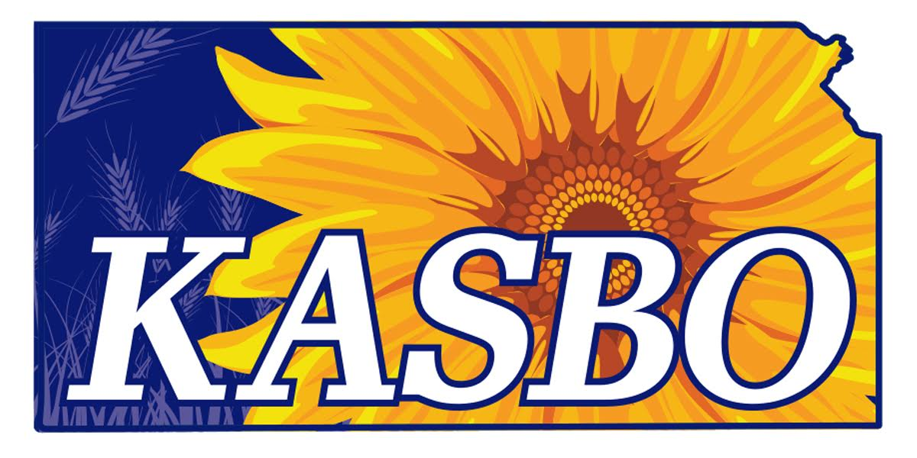
KANSAS ASSOICATION OF SCHOOL BUSINESS OFFICIALS
2021 Karen Schadel Memorial Scholarship Fund Application

Application Deadline March 01, 2021
Completed Application should be sent to Michael Speer
Email: speerm@usd445.org

Name _____________________________________ Title / Position ______________________
First / Middle Initial / Last

USD Name & No. ____________________________ Email ______________________________

Street Address, City & Zip ________________________________________________________

Work Phone Number _________________________ Years in School Business ______________

Signature __________________________________ Date_______________________________

Please answer the following questions. Please limit each response to 100 words or less.

- Have you attended a KASBO State Convention or ASBO International Meeting & Expo?
If yes, give dates and experience gained.

- What are your short and long term professional goals? How do your current job
responsibilities promote advancement of those goals?

- Why are you interested in applying for the KASBO Memorial Scholarship and what
value will you bring to the award?

- How will you utilize the experience of the KASBO Memorial Scholarship to contribute
to the school business profession?

