|  |  |  |
| --- | --- | --- |
| **Lesson** | **Intermediate Excel Training Course Content** | **Page** |
| 1 | **Absolute Cell Addressing** | **2** |
|  | Using Absolute References |  |
| 2 | **Naming Cells and Ranges** | **2** |
|  | Using the Create Method to Name Cells |  |
| 3 | **Data Consolidation** | **3** |
|  | Consolidating Data across Worksheets |  |
|  | Consolidating Data across Workbooks |  |
| 4 | **Using Formulae and Functions** | **4** |
|  | How to Enter a Formula |  |
|  | Using Sum/Average/Max/Min |  |
|  | Copying Formulas |  |
|  | **Lookup Functions** |  |
|  | Using V-lookup | **4** |
|  | Using H-lookup |  |
|  | Index | **5** |
| 5 | **Data Validation** | **6** |
|  | Using the Data Validation feature |  |
|  | Finding Invalid Data |  |
| 6 | **Conditional Formatting** | **7** |
|  | Setting Up Conditional Formats |  |
|  | Using Formulae in Conditional Formats |  |
| 7 | **Working with Data Lists** | **8** |
|  | Sorting |  |
|  | Subtotals |  |
|  | Filtering |  |
|  | Text to Columns |  |
| 8 | **Pivot Tables** | **10** |
|  | Using the Pivot Table Wizard |  |
|  | Modifying the Pivot Table |  |
| 9 | **Data Tables** | **13** |
|  | Creating Data Tables |  |
|  | One Way and Two Way Tables |  |
| 10 | **If Then Statements** | **15** |
|  | If then statement |  |
|  | Nested If then statement |  |
|  | **SHORTCUTS** | **17** |

**LESSON 1**



|  |
| --- |
| **Examples of absolute references:** |
| 1. $H$1 = Locks in the column and row. The formula will only use the data found in this cell. |
| 2. $H1 = Locks in the column. As you pull your formula down or across, the formula will always pull the data from column H for the corresponding row. |
| 3. H$1 = Locks in the row. As you pull your formula down or across, the formula will always pull the data from row 1 for the corresponding column. |

**LESSON 2**



|  |
| --- |
| **Create Method to Name Cells** |
| 1.Select the entire range of data from your naming cell in first col to values in second col |
| 2. Go to Formula Tab on the ribbon choose *Create from Selection* |

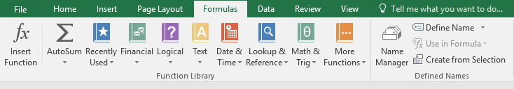

|  |
| --- |
| 3. Check the box next to Left Column and click OK |
| Doing this will cause Excel to automatically create defined names for each of the cells in first col for the values in second col. |

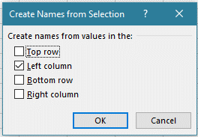



|  |
| --- |
| Once you have defined the names, you can create formulas with the names - |
| In this example C28 (Net Income) becomes C26-C27 becomes ***=Gross_Margin - Operating Expenses*** |

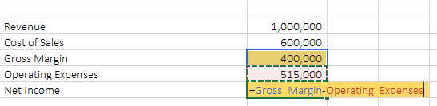

**LESSON 3**



|  |
| --- |
| 1. Start from clean worksheet. On the data tab, in the data tools group choose consolidate |

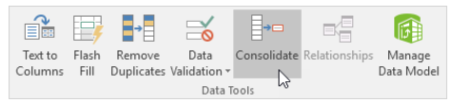

|  |
| --- |
| **Make Sure all three workbooks(files) are open - District 1, 2 and 3** |
| 2. Choose the sum function to sum the data |
| 3. Click in the reference box and select the range A1:E4 in the school1 data workbooks |
| 4. Repeat step three for the other workbooks choosing all the data for school2 and school3 |

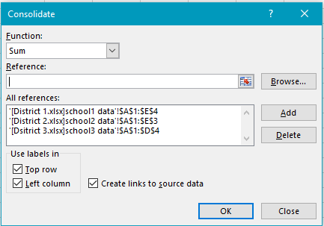

|  |
| --- |
| 5. Check Top Row, left column and create links to source data |

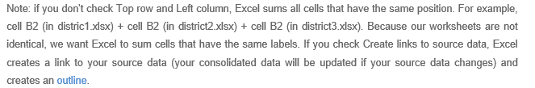

7. Click ok

**LESSON 4**



|  |
| --- |
| **Vlookup (VERTICAL LOOKUP)** |
| 1.Put your curser in the cell that you want to return data to |

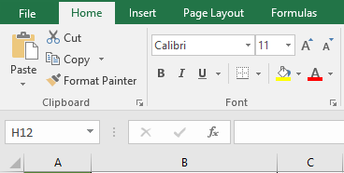

|  |
| --- |
| 2. Click on the fx icon on your ribbon. |
| 3. Type vlookup in the search box and then hit go. It should come up in the select function box below and you can double click on it to add to your cell |

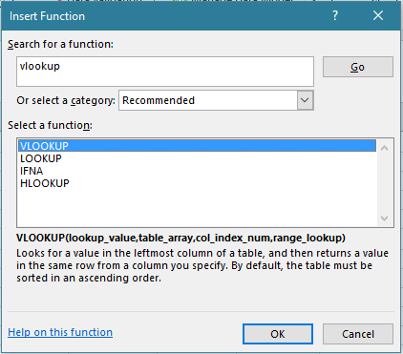

|  |
| --- |
| 4. At this point, the box below will pop up. |

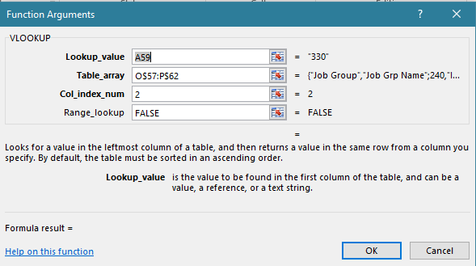

|  |
| --- |
| ***lookup value*** is saying look at the cell to the left |
| ***Table Array*** is telling where to look |
| ***Col_index_num*** is telling which col of data to return to your cell |
| ***Range_lookup* -** you choose false, so it will return an exact match |

|  |
| --- |
| **Some things to note -** |
| --> The look up value must be formatted correctly and directly to the left of the cell you are returning to |
| --> The look up value in you data must be formatted the exact same way as your look up value |
| --> When looking at the array, you must start with the column that matches your data exactly and the number you want to return, must be to the right of that |
| --> The table array should use absolute references to make sure it holds and looks in the same data for all your returned data should you fill your formula down |

|  |
| --- |
| **Index Function** |
| 1. Put your curser in the cell that you want to return data to - E161 |
| 2. Click on the fx icon on your ribbon. |
| 3. Type index in the search box and then hit go. It should come up in the select function box below and you can double click on it to add to your cell |
| 4. The Select arguments box will pop up. Double click on array, row num, col num |

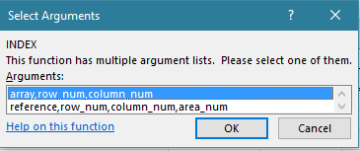

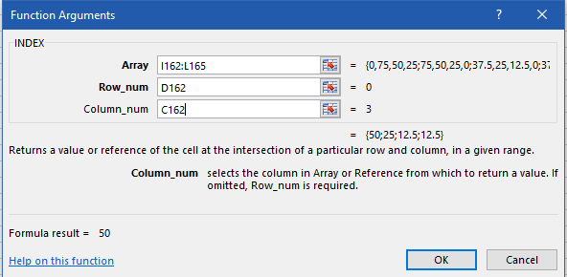

|  |
| --- |
| In this example: your student type is the row - D161 and your column is the quarter - C146. The yellow boxes are user inputs and the look up data is in the two data tables to the right. |
| This argument should look at the grid and return the intersection of the free and reduced student and quarter 1. |

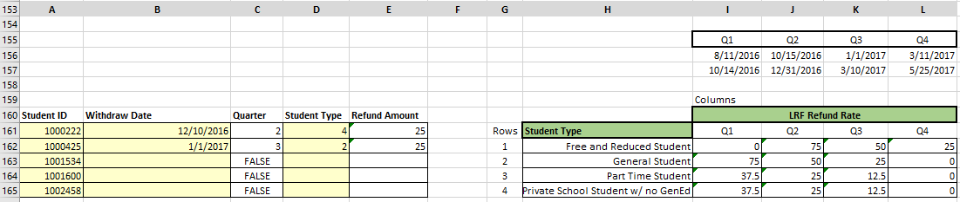

**LESSON 5**



|  |
| --- |
| **Set a Range of Numeric Values That Can Be Entered in a Cell** |
| You can place limits on the data that can be entered into a cell, you can set minimums and maximums or check for the effect an entry might have on another cell. |
| 1. Highlight cells B22:B29 |
| 2. On the Data menu, click Data Validation and click the Settings tab. |
| 3. In the Allow list, click Whole number. |
| 4. In the Data list, click between. |
| 5. In the Minimum box, enter 1. |
| 6. In the Maximum box, enter 12. |
| 7. Click OK. |

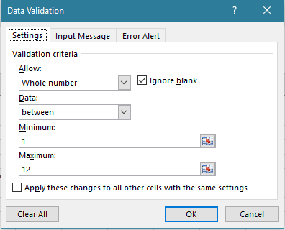

|  |  |
| --- | --- |
| **Example** | You have sent out a template for people to fill in. You want to make sure they return valid information. You want to make sure that no one can enter invalid data - |

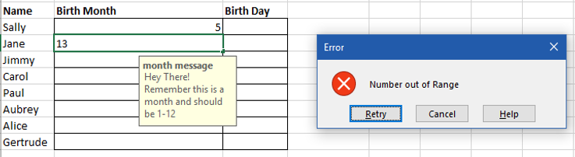

**LESSON 6**



|  |
| --- |
| **Conditional Formatting using formula** |
| **Shade Alternating Rows** |
| You can use Excel conditional formatting to shade alternating rows on the worksheet. |

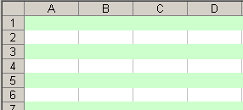

|  |
| --- |
| 1. Place your curser in cell A25 and choose CTRL+A - this will choose all the data in your sheet below |
| 2. On the Ribbon's Home tab, click Conditional Formatting, then click New Rule |
| 3. Click *Use a Formula to Determine Which Cells to Format* |
| 4. For the formula, enter    **=MOD(ROW(),2)** |
| 5. Click the Format button. |
| 6. On the Patterns tab, select a color for shading |
| 7. Click OK, click OK |

|  |
| --- |
| **Conditional Formatting** |
| 1. Place your cell in the column you wish to format |
| 2. On the Ribbon's Home tab, click Conditional Formatting, then click Highlight Cell Rules |
| 3. Choose what you want to determine - Greater than |
| 4. Enter the value in the Format Cells that are GREATER THAN box |

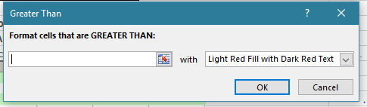

|  |
| --- |
| 5. click ok |

**LESSON 7**



|  |
| --- |
| **Copying Visible Cells Only** |
| *Often during our work, we filter our spreadsheets to show only certain data we care about at the time. I wanted to copy this data to another sheet. I would highlight all the data I could see and hit copy. When I pasted into another sheet, the filtered out data came with it, in addition to the data I wanted. The steps below outline how to copy over filtered data.* |
| 1. Highlight the data you want to copy. |
| 2. Hit F5. |

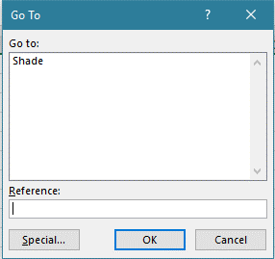

|  |
| --- |
| 3. Click the “Special” button in the lower left hand corner. |

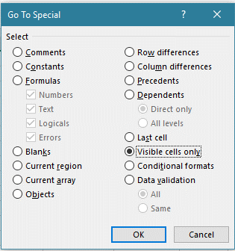

|  |
| --- |
| 4. Click on the “Visible Cells Only” Circle box. |
| 5. Hit OK. |
| 6. Press Ctrl “C” or Edit Copy. |
| 7. Paste data into the appropriate sheet. |
| 8. The visible data should have been copied over. |

|  |
| --- |
| **Text to Columns** |
| *To separate fixed-width text into multiple columns, follow these steps:* |
| 1. Insert Columns to the right for data to fill into |
| 2. Highlight the range of cells that includes text to be separated. |
| 3. Go to Data, Text to Columns. |
| 4. Select Fixed Width from step 1 of the wizard and click Next. |
| 5. Excel will guess at where the column breaks should go |

|  |
| --- |
| **Subtotals** |
| *To subtotal your data - follow steps below* |
| 1. Place your cell in the top leftmost cell and highlight all data - or CTRL+A |
| 2. On the Ribbon - choose Data - Subtotal |

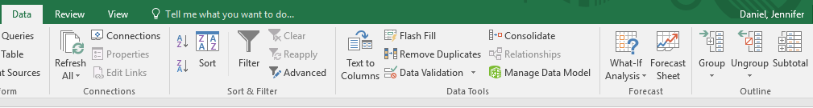

|  |
| --- |
| 3. At the pop up box - choose |

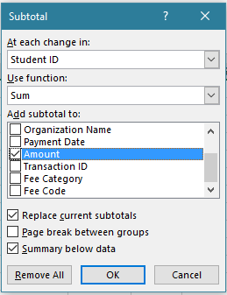

|  |
| --- |
| 4. Click OK |

**LESSON 8**



|  |  |
| --- | --- |
|  | **Creating a Pivot Table** |
| 1 | First step in using pivot tables is to make sure you have clean data. You need to make sure you do not have any blank rows or columns. Also, each column much have a unique header title and the workbook must be a named and saved file on your computer. You will also need to evaluate how you are wanting to consolidate your data - (by fee and total fee collected or by student/employee and total fees collected or by school and then total fees collected) |
| 2 | Once you have valid data, choose another tab in your workbook and click in the cell you want to insert your table. |

|  |  |
| --- | --- |
| 3 | Go to the insert tab and choose pivot table |

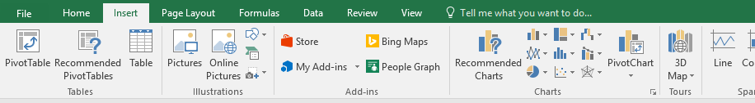

|  |  |
| --- | --- |
| 4 | This dialog box will show up - put your curser in the table/range and then click over to your set of data you wish to consolidate |

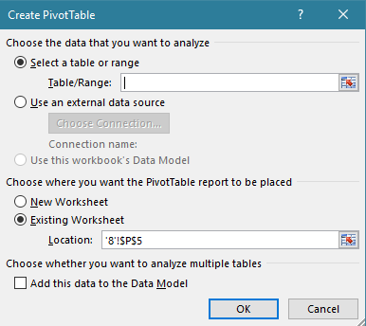

|  |  |
| --- | --- |
| 5 | To start: at the top left data cell, you can then highlight all the data including your header row. To grab all the data at once - click CTRL+A.  When you have chosen all the data, click ok and you will see this prompt below where you are inserting your table |

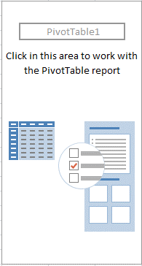

|  |  |
| --- | --- |
| 6 | Click on this box and it will open up the following prompt below |

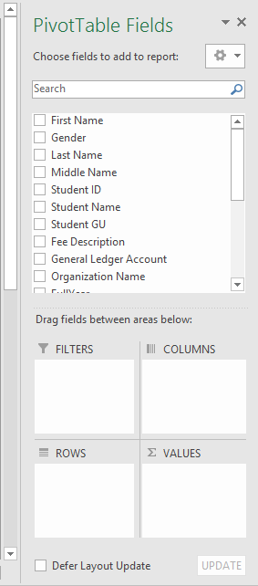

|  |  |
| --- | --- |
| 7 | Drag the header titles that you want consolidated into the boxes below (either rows or columns) and the data you want consolidated into the value box. This will create your table. |
| 8 | The last step is to always validate that the total of the column you are getting to, matches the grand total of your table |

|  |  |
| --- | --- |
|  | **Modifying** |
|  | *Changing numbers in your data file* |
| 1 | It is very important to note, that if you change anything in your data table, you need to go back in and refresh the table |

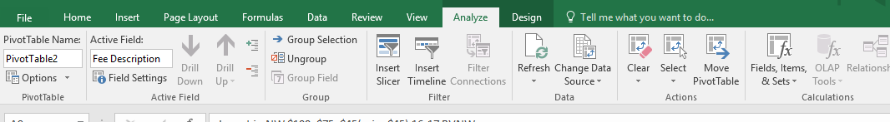

|  |  |
| --- | --- |
| 2 | click on the table and then go to your excel ribbon |
| 3 | choose analyze and then refresh |

|  |  |
| --- | --- |
|  | ***Adding Rows or Columns to Data Source*** |
| 1 | click on the table and then go to your excel ribbon |
| 2 | choose analyze |
| 3 | Then Change Data Source - this will give you the data source box below again to capture all of your numbers. |

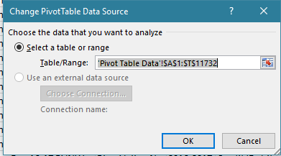

|  |  |
| --- | --- |
| 4 | This takes you back to your tab of data and you can simply choose A1 and highlight all of your data again - CTRL+A |

**LESSON 9**



|  |  |
| --- | --- |
|  | **Insert a Table** |
| 1 | Click in any cell within the data set |
| 2 | On Insert tab, click table |

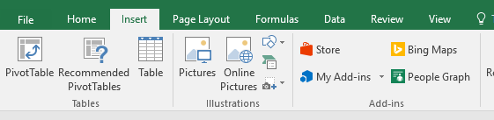

|  |  |
| --- | --- |
| 3 | Excel automatically selects the data for you. Check 'My table has headers' and then click OK |

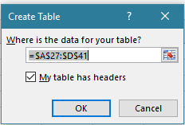

|  |  |
| --- | --- |
|  | The result is a nicely formatted table. It may seem normal, but this has a lot of great features. |

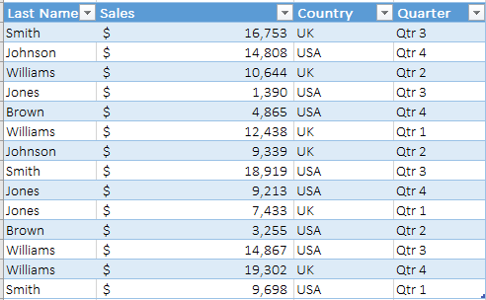

**\* From here you can choose the design tab and create more functionality**

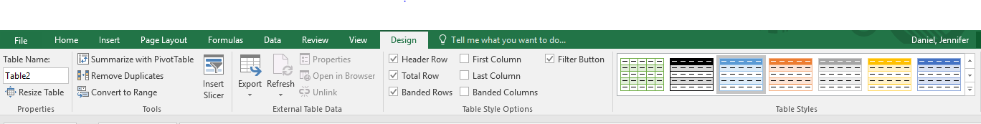

|  |  |
| --- | --- |
|  | **Two Variable Data Tables - What if Analysis** |
| 1 | Copy the original formula entered in cell C61 into cell B64 by typing = (equal to) and then clicking cell C61. |
|  | For a two-variable data table, the copy of the original formula must be entered at the intersection of the row and column input values. |
| 2 | Select the cell range B64:F74. |
|  | The range of the data table includes the formula along with the various growth rates. |
| 3 | Choose What-If Analysis→Data Table in the Data Tools group on the Data tab. |
|  | Excel opens the Data Table dialog box with the insertion point in the Row Input Cell text box. |
| 4 | Click cell C60 to enter the absolute cell address, $C$60, in the Row Input Cell text box. |
| 5 | Click the Column Input Cell text box and then click cell C59 to enter the absolute cell address, $C$59, in this text box. |

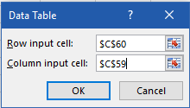

|  |  |
| --- | --- |
| 6 | Click OK |
|  | Excel fills the blank cells of the data table with a TABLE formula using C60 as the Row Input Cell and C59 as the Column Input Cell. |

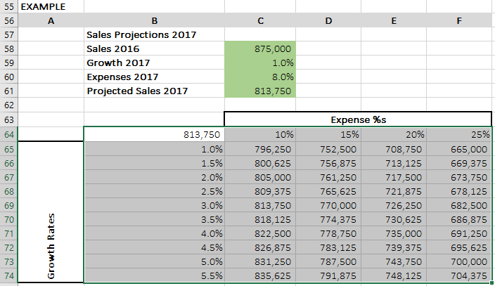

**LESSON 10**



**If Then Statements….**

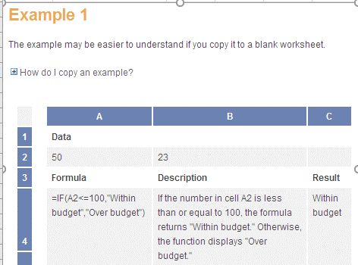

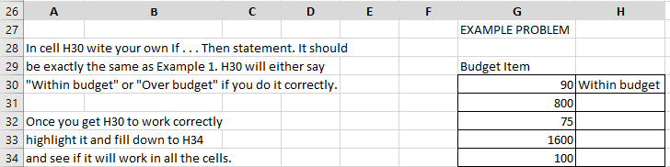



**Nested If Thens….**

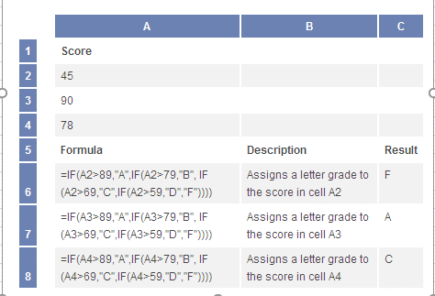

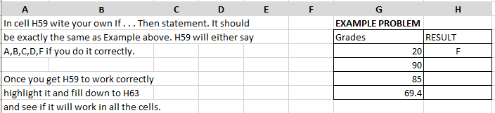



|  |  |
| --- | --- |
| **Shortcut** | Description |
| **F2** | [Edit the selected cell.](http://www.computerhope.com/jargon/c/cell.htm) |
| **F3** | After a name has been created, F3 will paste names. |
| **F4** | Repeat last action. For example, if you changed the color of text in another cell, pressing F4 will change the text in cell to the same color. |
| **F5** | Go to a specific cell. For example, C6. |
| **F7** | Spell check selected text or document. |
| **F11** | [Create chart from selected data.](http://www.computerhope.com/jargon/c/chart.htm) |
| **Ctrl + Shift + ;** | Enter the current time. |
| **Ctrl + ;** | Enter the current date. |
| **Alt + Shift + F1** | [Insert New Worksheet.](http://www.computerhope.com/jargon/s/spreadsh.htm) |
| **Alt + Enter** | While typing text in a cell, pressing Alt + Enter will move to the next line, allowing for multiple lines of text in one cell. |
| **Shift + F3** | [Open the Excel formula window.](http://www.computerhope.com/jargon/f/formula.htm) |
| **Shift + F5** | Bring up search box. |
| **Ctrl + 1** | Open the Format Cells window. |
| **Ctrl + A** | Select all contents of the worksheet. |
| **Ctrl + B** | Bold highlighted selection. |
| **Ctrl + I** | Italic highlighted selection. |
| **Ctrl + K** | [Insert link.](http://www.computerhope.com/jargon/l/link.htm) |
| **Ctrl + S** | Save the open worksheet. |
| **Ctrl + U** | Underline highlighted selection. |
| **Ctrl + 1** | Change the format of selected cells. |
| **Ctrl + 5** | [Strikethrough highlighted selection.](http://www.computerhope.com/jargon/s/striketh.htm) |
| **Ctrl + P** | Bring up the print dialog box to begin the printing process. |
| **Ctrl + Z** | Undo last action. |
| **Ctrl + F3** | [Open Excel Name Manager.](http://www.computerhope.com/jargon/n/name.htm) |
| **Ctrl + F9** | [Minimize current window.](http://www.computerhope.com/jargon/m/minimize.htm) |
| **Ctrl + F10** | [Maximize currently selected window.](http://www.computerhope.com/jargon/m/maximize.htm) |
| **Ctrl + F6** | Switch between open workbooks or windows. |
| **Ctrl + Page up** | Move between work sheets in the same document. |
| **Ctrl + Page down** | Move between work sheets in the same document. |
| **Ctrl + Tab** | Move between Two or more open Excel files. |
| **Alt + =** | Create a formula to sum all of the above cells. |
| **Ctrl + '** | Insert the value of the above cell into the cell currently selected. |
| **Ctrl + Shift + 1** | Format number in comma format. |
| **Ctrl + Shift + 4** | Format number in currency format. |
| **Ctrl + Shift + 3** | Format number in date format. |
| **Ctrl + Shift + 5** | Format number in percentage format. |
| **Ctrl + Shift + 6** | Format number in scientific format. |
| **Ctrl + Shift + 2** | Format number in time format. |
| **Ctrl + Arrow key** | Move to next section of text. |
| **Shortcut** | Description |
| **Ctrl + Space** | [Select entire column.](http://www.computerhope.com/jargon/c/column.htm) |
| **Shift + Space** | [Select entire row.](http://www.computerhope.com/jargon/r/row.htm) |
| **Ctrl + -** | Delete the selected column or row. |
| **Ctrl + Shift + =** | Insert a new column or row. |
| **Ctrl + Home** | Move to cell A1. |
| **Ctrl + ~** | Switch between showing Excel formulas or their values in cells. |